- Purpose
  - The purpose of this document is to describe the procedure for placing photos of shipped machines into folders.
- Scope
  - This SOP applies to all equipment shipping members.
- Responsibilities
  - The operations manager/supervisor is responsible for enforcing this SOP.
- Materials
  - Machine photos
- Definitions

- Procedure
  - Log into computer in packaging area:
User name: Jequipment
Password: Equ!pm3nt#1bg

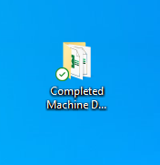
  - Click on Completed Machine Documents located on your desktop.

  - Click on Completed Documents for the current year

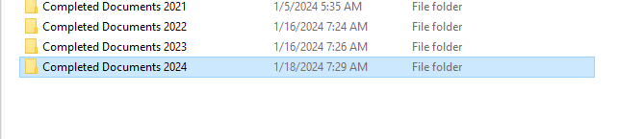
  - You will need to create a folder. Right click on the right side of the page select New, then select Folder. Name the folder using the 7 digit serial number of the machine.
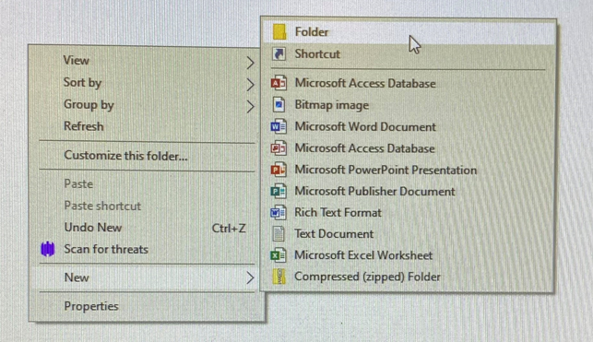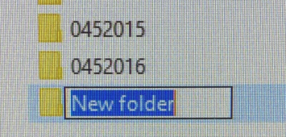

  - Rename pictures using the serial number for picture A & B. Place photos in the folder.
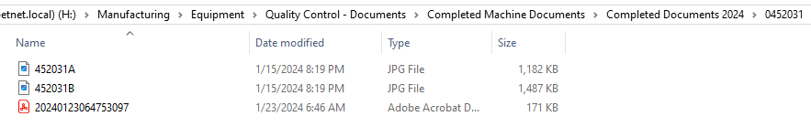

  - This is the location of the Completed Machine Documents if unable to use shortcut on desktop.

- References (optional section as needed)

- Training Guide

Functional Training Groups Requiring Training
Equipment Assembly Group

- SOP Change Control

Date of Change | Reason for Change
Rev 01 | This is the first version of the S.O.P. hence there are no revisions to this document.

Approvals

Submitter/Author Approval:__________________________________ Date:______________________

Management Approval:______________________________________ Date:______________________

QAU Approval:_____________________________________________ Date:______________________

